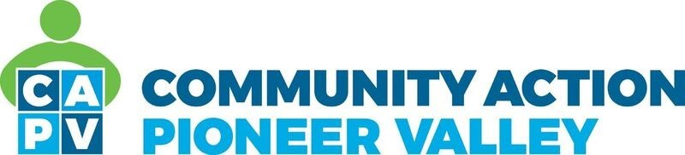

ENERGY PROGRAMS INTAKE/CERTIFIER

The Energy Programs Fuel Assistance program has a full time opening for an intake/certifier position. This position is responsible for interviewing and completing the application intake for individuals applying for the Fuel Assistance Program. The ideal candidate will have five years of related experience with client services and compiling financial information.

This is a full year position at 37.5 hours a week. Pay range: $17.63-$18.70. Excellent benefits, training, supervision and collaborative work environment. Bilingual (Spanish, English, Russian) preferred.

Excellent benefits, training, supervision and collaborative work environment. We offer Health Insurance (CAPV pays 80% of the premium*), Dental Insurance, Retirement Plan, Flexible Spending Plans (medical and dependent care), Vision Insurance, Long-Term Disability Insurance (CAPV pays 100% for the benefit), Sick, Vacation, Personal time and 12 paid Holidays. Community Action is a qualifying employer for the Public Service Loan Forgiveness program.

To apply please go to https://www.communityaction.us/job-openings for full job description and information regarding benefits.

Community Action is committed to a diverse workforce. AA/EOE/ADA

